INDUSTRIAL TRAINING PROJECT REPORT ON

WEATHER APP IN PYTHON

SUBMITTED IN THE PARTIAL FULFILMENT OF THE
REQIREMENT
FOR THE AWARD THE DEGREE
OF

BACHELOR OF TECHNOLOGY COMPUTER SCIENCE

AND ENGINEERING


Submitted To: Submitted By: -
Mr. Raman Kumar Name- Navjyoti Sharma
Under the Supervision Roll no: -22021003009
Ms. Bharti Mahajan Branch- CSE (7th Sem)

Green Hills Engineering College (H.P)- 173229
(Affiliated to Himachal Pradesh Technical University Hamirpur, H.P)

CANDIDATE’S DECLARATION

I, Navjyoti, student of Btech (Computer Science and Engineering) at Green Hills Engineering College, Gandhigram, bearing Roll Number 22021003009 session 2022-2025, hereby declare that the project entitled “Weather App In Python” submitted to Computer Science and Engineering Department as a partial fulfilment of the requirements for the award of degree of Bachelor of Technology, has been carried out under the guidance of Ms. Bharti Mahajan.
The project is an original piece of work and has not formed the basis for the award of any other degree of any other college.

Navjyoti Sharma

CERTIFICATE

This is to certify that, this thesis report titled “Weather App in Python” submitted by Navjyoti Sharma bearing
Roll Number 22021003009 is bonafide record of the industrial training carried out by him in partial fulfilment for the requirement of the award of Bachelor of Technology (Computer Science and Engineering) degree from Green Hills Engineering College, Gandhigram, Solan.

SUPERVISOR
Ms. Bharti Mahajan
Department of CSE
GHEC, Gandhigram

ACKNOWLEDGEMENT
The present work will remain incomplete unless I express my feelings of gratitude towards a number of persons who delightfully co-operated with me in the process of this work.
I am highly indebted to my supervisor Ms. Bharti Mahajan, Professor, Department of Computer Science and Engineering, Green Hills Engineering College for encouragement. In spite of busy schedule and pressure of academic work, always spared time for me and his guidance, precious and genial, always kept me on the right track, in my work.
I am thankful to other faculty members, Raman sir and staff of Department of Computer Science and Engineering, Green Hills Engineering College.
Last but not least , I acknowledge my indebtness to my parents and friends for their patience, constant cooperation and inspiration.

Navjyoti Sharma (22021003009)

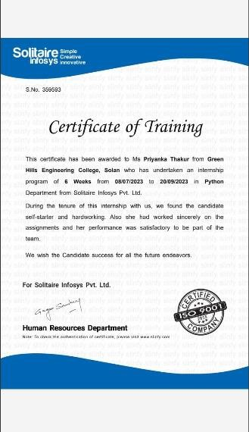

ABSTRACT

Nowadays we face a huge problem that knowing real weather status instantly in such a place we need to know.it is often complex and challenging skill that involves observing and processing vast amount of data Weather systems can range from small, short lived thunderstorms only a few miles in diameter that last a couple of hours to large scale rain and wind up to a thousand miles in a diameter, and lasting for days. So most of the time we cannot get the real weather forecast and face a lot of troubles. We have another problem in weather forecasting. To do this effectively technology can help a lot.In this android app is developed with the help of Android Studio and API we will help the user to get to know about real-time weather updates of a particular place.

TABLE OF CONTENTS
Contents
- INRODUCTION……………….………………………………………… 8
  - Introduction To Weather App………………………...………………... 8
  - Problem Definition……...………………………………………………. 8
  - Objectives………………………………………………………………. 9
  - Scope……………………………………………………………………...10
- LITERATURE REVIEW………………………………………………..10
- REQUIREMENT AND SPECIFICATION…………………………….11
  - Hardware Requirements……………………………………………….12
  - Software Requirements…………………………………………………12
- METHODOLOGY……………………………………………………….12
  - Analysis…………………………………………………………….…….12
  - Design………………………………………………………….………...13
  - Coding……………………………………………………………………14
  - Testing…………………………………………………………………....14
  - Implementation………………………………………………………….15
- CONCLUSION AND SUMMARY…………………………………….16
- REFERENCES………………………………………………………….17
- APPENDICES…………………………………………………………... 17

1. INTRODUCTION
1.1 Introduction to Weather App
Python is a popular and flexible programming language that is well-known for its ease of use, readability, and large library. It is now a well-liked option for many applications, such as artificial intelligence, machine learning, data science, and web development.
To summarize and brief in short, Weather App is the application of science and technology to predict the conditions of the atmosphere for a given location and time. People have attempted to predict the weather informally for millennia and formally since the 19th century. Weather forecasts are made by collecting quantitative data about the current state of the atmosphere, land, and ocean and using meteorology to project how the atmosphere will change at a given place. It is very important to get educated on the current weather situation of a particular location as preferred since it affects the day-to-day life of everyone. It is more effective if we can get quickly updated on current weather status of a required location, as it makes it easy to handle not only our activities, but also our livelihoods too. A huge problem that we are facing nowadays is inability to know real weather status in such places. So if we need to know the current situation in a certain place, it is better to ask from a person who is in that area recently or currently. He is a better source than any prevailing weather information.

Problem Definition

1.2.1 API Access:
Choose a weather API (e.g., OpenWeatherMap, Weatherbit, etc.).
Get an API key by signing up on their website.
    - HTTP Requests:
Use the requests library to make HTTP requests to the weather API with your API key.
    - Parsing JSON:
Retrieve the weather data in JSON format and parse it using Python's built-in json library.
    - GUI with Tkinter:
Create a Tkinter GUI with labels, entry fields, and buttons for user interaction.
    - Display Weather Information:
Update the GUI to display the relevant weather information fetched from the API.

1.3 Objectives
The objectives of a weather app in Python typically include:
    - Real-time Weather Information: Provide users with up-to-date and accurate weather details for a specified location.

    - User-Friendly Interface: Design an intuitive GUI using Tkinter to facilitate easy interaction, allowing users to input a city and retrieve weather information effortlessly.

    - Integration with Weather API: Connect the app to a reliable weather API, such as OpenWeatherMap, to fetch and display real-time weather data.

    - Error Handling: Implement robust error handling mechanisms to manage invalid user inputs or potential issues with API requests, ensuring a smooth user experience.

    - Modular Code Structure: Organize the code into modular functions for better maintainability and scalability, adhering to best coding practices.

    - Testing and Quality Assurance: Thoroughly test the app to verify accurate data retrieval, proper error handling, and overall functionality, ensuring a high-quality user experience.

1.4 Scope
The future of weather applications is promising, with the increasing demand for realtime and accurate weather information. One potential development is the improvement in accuracy through the use of advanced data collection and analysis techniques, as well as sophisticated algorithms. This will lead to more reliable weather forecasts, helping individuals and organizations make informed decisions. Personalization is another area where weather applications are likely to evolve. These apps will offer customized forecasts and alerts based on a user's location, preferences, and behavior. This personalization will make weather information more relevant and useful for the user. Finally, weather applications will become more intuitive and userfriendly, using visualizations and other tools to help users understand complex weather data more easily. This will make weather information more accessible and understandable for everyone, leading to better-informed decisions and actions. Overall, the future scope of weather applications is bright, with continued innovation and advancement in this field expected in the coming years.

2. Literature Review
Weather App as the name goes is an advanced yet highly promising system helping a tourist or any user to get accurate and best data in no time. This System is an Android Application and uses Web designing languages as its Front End and APIs. The Application acts as a weather forecaster giving out outputs to the user for every input given to the system. The System is highly reliable as it uses foursquare API which are very accurate and same goes for the weather conditions. This System tries the user to give a heads-up giving the weather conditions to make sure that the user will be comfortable to visit the desired place. The User has options to select for the places he wants to visit, for instance parks, beaches, monuments or food joints and so on; the system will ask whether he is searching for the current locality or some other place. The System is very flexible in changing places to display places if the user wishes to. Now, one can simply visit their portal, search for their destination and they will easily find the information about weather conditions of their destination for that particular date or future days.
Need of Application
Weather Forecasting is crucial since it helps to determine future climate changes. With the use of latitude, we can determine the probability of snow and hail reaching the surface. We are able to identify the thermal energy from the sun that is exposed to a region. Climatology is the scientific study of climates, which in simple words mean weather conditions over a period. A bunch of studies within atmospheric sciences also takes the help of the variables and averages of short-term and long-term weather conditions accumulated. Climatology is different from meteorology and can be divided into further areas of study. Different approaches to this segment can be taken. Currently, our primary research goal is to motivate and help the development of efficient and effective measures of Environmental activities.

Seasons and nature play a major role in agriculture and farming. When it comes to the farming of various fruits, vegetables, and pulses, temperature is extremely important. Farmers didn't have a better understanding of weather forecasts before, so they had to rely on estimates to do their jobs. They do, however, sometimes suffer losses as a result of inaccurate weather forecasts. Farmers will now get all of their forecasts on their smartphones, thanks to advances in technology and the use of unique weather forecasting mechanisms. Of course, education in this area is critical, but the majority of the farmer community at this point understands the fundamentals, making it simple for them to use the features.

2. REQUIREMENT SPECIFICATION

2.1 HARDWARE REQUIREMENTS :
Processor Brand : Intel
Processor type : Core i5
Processor speed : 2.10ghz
Processor : 1 RAM
Size : 8GB
Memory Technology : DDR4
Computer Memory Type : DDR4 SDRAM
SSD Size : 256 GB

2.2 SOFTWARE REQUIREMENTS:
Operating System : Windows 10
Programming language : Python 3.11.4
Code editor : VScode

3. Methodology
3.1 Analysis

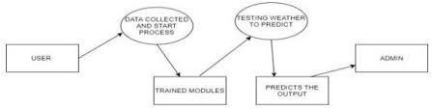

Figure 1: Level Zero DFD

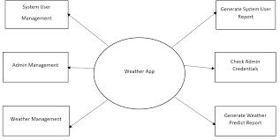

Figure 2: Level One DFD

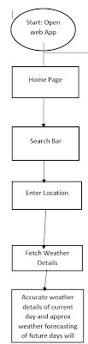

Figure 4: Application Flowchart

3.2 Design
Creating a weather app in Python involves a combination of GUI design, API integration, and data visualization. To get started, you can use the Tkinter library for the graphical user interface. Design a simple layout that includes input fields for users to enter a location and a button to fetch the weather data.
For weather data, you'll need to choose a weather API, such as OpenWeatherMap or
Weatherbit, and obtain an API key. Use the requests library to make API calls and retrieve the necessary information, such as temperature, humidity, and weather conditions.
Once you have the data, organize it in a readable format and display it on the GUI. Consider using labels or text widgets to present the current weather and forecast information. You can enhance the user experience by incorporating icons or images to represent weather conditions.
Remember to structure your code efficiently, using functions to modularize different tasks.
This makes it easier to maintain and expand your weather app in the future. Overall, the key elements are a well-designed GUI, seamless API integration, and thoughtful presentation of weather information for a user-friendly experience.

3.3 Coding

To create a weather app in Python, start by installing necessary libraries like Tkinter for the GUI and requests for API calls. Begin by designing a simple interface using Tkinter widgets such as Entry, Button, and Labels. The Entry widget can take user input for the location, and a Button triggers the weather data retrieval process.
Choose a weather API, sign up for an account, and obtain an API key. For example, using OpenWeatherMap API, make HTTP requests to fetch weather data based on the user's input. Parse the JSON response to extract relevant information like temperature, humidity, and weather conditions.
Next, design the GUI to display the retrieved weather information. Use Labels or Text widgets to present the data in an organized and readable format. Consider incorporating icons or images to represent weather conditions, enhancing the visual appeal of the app.
In conclusion, a well-organized Python weather app involves designing an intuitive GUI, integrating a reliable weather API, parsing and displaying data effectively, and implementing error handling for a smooth user experience.

3.4 Testing
3.4.1 API Request Handling:
- Test that the app properly constructs and sends requests to the weather API.
- Mock the API responses to simulate different scenarios (success, errors).
3.4.2 Data Parsing:
- Ensure that the app correctly parses the JSON data received from the API.
- Test different weather conditions and temperature formats.
3.4.3 User Input Handling:
- Test the app's response to different user inputs (valid and invalid cities).
- Check if the app gracefully handles empty input or unexpected characters.
    - GUI Interaction:
- Validate the interaction between the GUI components (entry, button) and the underlying logic.
- Test the GUI update with weather information after a successful request.
    - Error Handling:
-Verify that the app handles errors (API errors, network issues) appropriately.
-Test the display of error messages to the user.

    - Integration Testing:
Perform end-to-end tests by simulating user input and checking the entire process from input to displayed weather information.

3.5 Implementation
Creating a weather app in Python involves combining a graphical user interface (GUI) framework, like Tkinter, with an API for weather data retrieval. Begin by designing a clean and intuitive interface, incorporating input fields for the user to specify the location and a button to trigger data retrieval. Choose a reliable weather API, such as OpenWeatherMap, and obtain an API key for authentication.

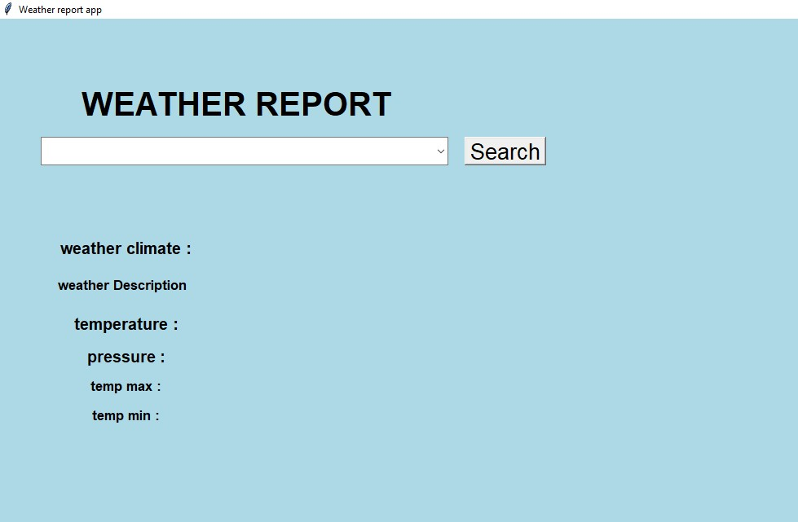

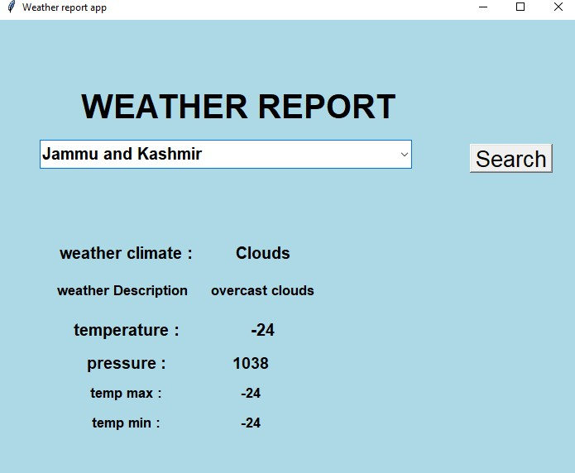

4. Summary and Conclusions:

The Python weather app employs Tkinter for the GUI and interacts with a weather API, such as OpenWeatherMap, for live weather data. Users input a city, initiating API calls to retrieve details like temperature, humidity, and weather conditions. The app boasts robust error handling for both user inputs and API responses, ensuring a smooth user experience. Its modular code structure enhances maintainability, with visual elements like icons adding to the user-friendly interface. Key software requirements encompass Python, Tkinter, the requests library, and a valid API key. The system development process spans requirements analysis, design, API integration, UI implementation, testing, and deployment. The weather app stands as an accessible tool for users to obtain current and accurate weather information, reflecting a synthesis of efficient coding practices, visual appeal, and reliable data retrieval. Ongoing maintenance and updates contribute to the app's resilience and relevance in delivering timely weather insights to users.
From this we can conclude that a weather application can be of great help to users, especially with the increasing use of smartphones and the convenience they provide. Weather applications can be developed for various platforms, but due to the large user base of Android, developing an Android weather app would allow for access to a larger customer base. Android apps are also comparatively cheaper and more accessible, making it easier for users to have access to the app. The weather application will provide users with real-time weather information, forecasts, and other weatherrelated data, which can help them make better decisions about their day-to-day activities. Additionally, the weather app can provide users with statistical information and trends, which can help them monitor weather patterns over time and make data-driven decisions. Overall, a weather application can be a useful tool for users to stay informed about weather conditions and make better decisions based on that information

5. REFERENCES
(Srivastava, n.d.) https://www.askpython.com/python/examples/gui-weather-app-in-python
(geeksforgeeks, n.d.)https://www.geeksforgeeks.org/weather-app-in-python-using-tkinter-module/
(open weather , n.d.)https://openweathermap.org/

6. APPENDICES

  - Dependencies:

List of Python libraries/modules used (e.g., requests, Tkinter).
Any external APIs or services (e.g., OpenWeatherMap API).

  - Installation Guide:

Step-by-step instructions on how to install and set up the app.
Include any specific configurations or settings.

  - API Key Handling:

Guidelines on obtaining and using API keys, ensuring security.

  - Code Structure:

Overview of the app's file structure.
Explanation of major functions and their roles.

  - Error Handling:

Strategies implemented for handling potential errors. Troubleshooting tips for common issues.

